Assignment 3
Two-Dimensional Array ADT
Description
Write a Two-Dimensional Array ADT that is based on the UML class diagram shown below.

Class
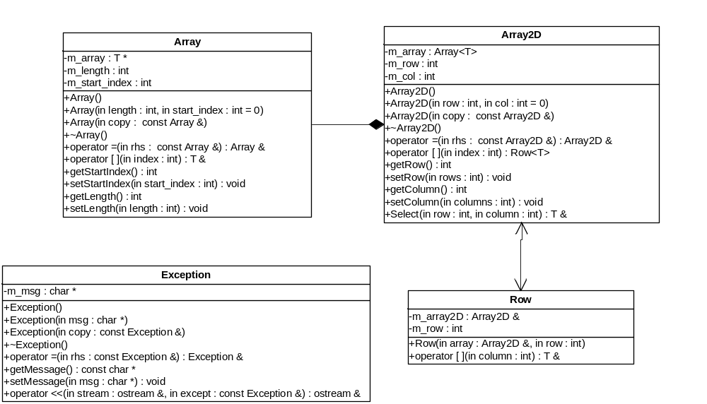

Stipulations
- Provide mutators for both the rows and columns.
- Make sure the user never goes out of bounds. If they do, throw an exception.
- Use an Exception class to throw if they do go out of bounds.
- Modify the class so that the subscript operators can be called from const objects. Hint: You can only call const methods from const objects.

